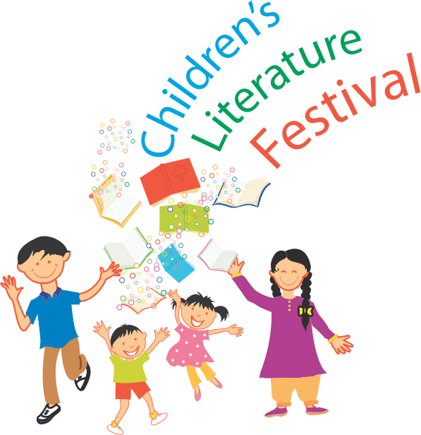
A Peaceful Pakistan, Pakistan For All
Art Campaign

Name: _____________________________________________________________
Age: _______________ Grade:_________________________________________
Art Teacher: ________________________________________________________
School:_____________________________________________________________

Name of the art work submitted:
__________________________________________________________
A brief description of the art work:
__________________________________________________________________________________________________________________________________________________________________________________________________________________________________________________________________________________________________________________________________________________________________________________________________________________
Consent:
I hereby allow my son/daughter’s art work to be the property of A Peaceful Pakistan, Pakistan for All art campaign.
Parent’s Signature:__________________________________________
Parent’s Name: _____________________________________________

#PakistanForAll
#OneBloodOneNation

